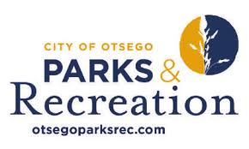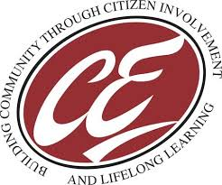

The City of Otsego Parks & Recreation in partnership with Community Education offers:

WOMEN’S VOLLEYBALL LEAGUE
We are back and ready for some fun! Adult Women’s Volleyball League consists of an 8-game regular season schedule with a single elimination tournament to follow. Matches are on Sunday evenings at 6:00,7:00 & 8:00pm. at Prairie View Elementary.
There will be a captain’s meeting at 6:00 p.m. on Jan 7th via zoom.

For more information and to register, go to otsegoparksrec.com

Winter League: January 14 – March 10, 2024
Single elimination tournament March 17 and March 24
April 7 is weather make up
Cost/Team: $200
Deadline to Register: Dec 17th

